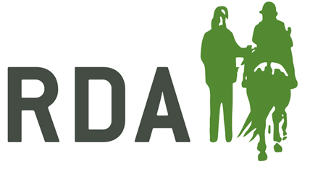
ROLE PROFILE
DRESSAGE LEAD

The Role:
Dressage is one of our most popular activities and has a direct link to British Dressage and the Paralympic pathway. It is a key role and ensures RDA activity is both aligned with this pathway for those with a desire to progress through competition but is also fun and engaging at all levels for all riders.

The Dressage Lead plays a vital role in providing direction and development of RDA Dressage activities and supporting the promotion of RDA Dressage.
As Lead, you will have the opportunity to contribute to the development of RDA UK as a national organisation, through your membership of the Operations Planning Committee, which reports directly to the RDA Board of Trustees.
Responsibilities:
- Lead the activity of Dressage, delegating responsibilities and tasks if needed.
- Chair any Working Groups for Dressage.
- Work alongside a variety of teams within National Office which will include Training and Education, Competitions, National Championships and Group Development.
- Ensure effective communication across the wider Dressage community, in particular with Regional Dressage Reps and Dressage Judges by Zoom, phone, email and in person where necessary.
- Support the National Office team and RDA Groups with Dressage queries and rulebook updates.
- Play a key role in the organisation of any Dressage Judge training.
- Liaise with British Dressage via Zoom Meetings or in person bi-monthly.
- Support National Championships Co-ordinator with recruitment and allocation of Dressage Judges.
- Attend National Championships. Liaise with Judges, Stewards, Vets, Scorers and manage any appeals for Dressage.
- Be committed to the growth of Dressage within the RDA network.
- Attend and represent Dressage on the Operations Planning Committee.

Commitment
This is a voluntary role within RDA and it is an important one. It is anticipated that this person will:
- Attend 4 Operational Planning Committee Meetings per year (currently 2 hours each by Zoom)
- Chair 4 Regional Dressage Representatives Meetings per year (currently 2 hours each by Zoom)
- Run/ support at least 1 Dressage Judge training session (in person or by Zoom)
- Attend National Championships (3 days during the middle of July)
- Provide support (up to approx. 1 day per month) to Regional Dressage Reps, Chair Working Group/s (e.g. review of RDA dressage tests), manage the list of RDA Dressage judges, update rule book.

Person Specification:

We are therefore looking for someone with the enthusiasm and drive to promote and advance the activity of Dressage in RDA.

The successful candidate will have:
- Significant Para Dressage/RDA Dressage experience, ideally as a Judge or an experienced RDA/ Para Dressage rider or coach .
- Great communication skills; to both listen to feedback from Regional representatives, competitors, judges. As well as share information and knowledge across the extensive RDA networks about Dressage
- Great teamworking skills, as you will be working with National Office staff, British Dressage, Dressage judges as well as RDA participants and volunteers.
- Enthusiasm, bringing new ideas to Dressage in RDA and an openness to change
- A good understanding of technology, or willingness to learn, including the use of Zoom for training and meeting purposes.
- A real commitment to continuing to improve and grow Dressage within RDA for the benefit of participants, working closely with staff in National Office.

Method of Appointment:
The Dressage Lead is appointed in consultation with the Volunteer Appointment Committee.

For further information, please contact Faye McKenning fmckenning@rda.org.uk.

