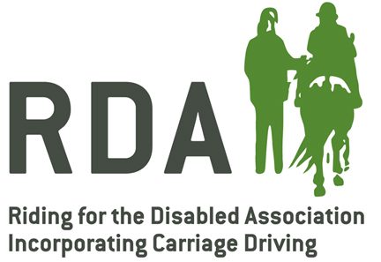
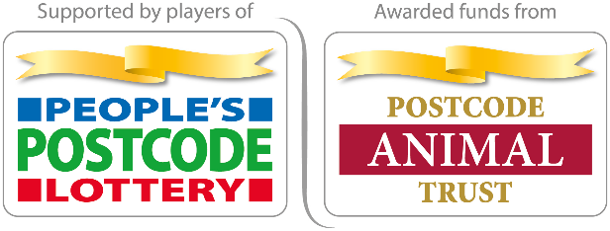

RDA ‘GRAND DAY OUT’
June 2021

Thanks to players of People’s Postcode Lottery, we can offer 50 groups up to £100 for a ‘Grand Day Out’ this Summer. Get your thinking caps on then apply!

- Name of Group

- Your name

- Your email address

- Total amount being applied for up to £100

- Short description of your planned ‘Grand Day Out’

- Does your Grand Day Out include any equestrian activities No ☐ / Yes ☐

- How many participants do you hope to include out of the total you have at your group? (eg 5 out of 20)

- Any further relevant information (optional)

- I understand that, if a choice has to be made, priority will be given to groups who have struggled to reopen and would benefit from getting their participants together, and where the day out will include a significant proportion of the total participant numbers. Please check this box to confirm this ☐

- I understand that, if successful, we will need to complete an Insurance Form and have a completed risk assessment for all planned activities before the event takes place. Please check this box to confirm this ☐

- After the event, we are happy to share information (number of attendees, volunteers, description of the event, photos) with RDA UK. Information will be used for publicity and marketing and shared with funders. Photos and any names must have prior consent for use by RDA UK and funders. Please check this box to confirm this ☐
Please complete and return this application by email to info@rda.org.uk. In the subject line of the email please write “Grand Day Out Application + your group’s name”

We will aim to respond to your application within a week of submission whether you have been successful. Please therefore allow sufficient time between submission of the application and your planned Grand Day Out. All days out should be completed by Sunday 26 September.

Grants will be subject to RDA UK’s normal terms and conditions for grants.
If you have any questions or queries about the application, please contact Anna Hall at ahall@rda.org.uk

