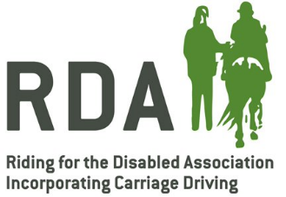
Declaration Form for Activity Leader
To be filled out by Activity Lead applicant and completed by Group trustees and Group Coach before sending to the Training and Education Team at RDA National Office.
RDA Group Name:
Mr/Mrs/Miss/Ms
Address:
Postcode:
Telephone Number:
Mobile:
Email:
External Qualifications:
Please sign here to say that you have seen the following:
COMPLETED GREEN CARD
PREPARING AND ASSISTING
EQUINE KNOWLEDGE
DISABILITY AWARENESS
SAFEGUARDING CERTIFICATE
Please sign here to say that you are confident the above-named person can deliver unmounted, static sessions safely and in an appropriate manner.
(Reviews will take place every year from the date of this form)
GROUP TRUSTEE |  |  | Date:
GROUP TRUSTEE |  |  | Date:
GROUP COACH |  |  | Date:
ACTIVITY LEADER |  |  | Date:

