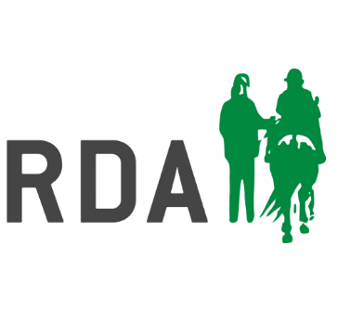This form must be completed by an RDA Coach in conjunction with a County Coach/Regional CD Driving Rep.

|  |  |  |
| --- | --- | --- |
| Participant Name (print full name): | Date of hat assessment: | |
| Group: | Region: | |
| Explain why a standard Riding Hat was not suitable: | | |
| Any other additional / relevant information (hair type/style): | | |
| Relevant Medical Information: | | |
| Which riding hats have been tried:  Brand Name - | | |
| Explain why the chosen hat is suitable:  The hat must display a current safety standard and quality assurance mark (BSI, Kitemark) | | |
| Date of next annual hat assessment (if applicable): | | |
| RDA Coach Name  County / Regional Coach or Regional Driving Representative Name | | Signature:  Signature:  Date: |
| *Participant / Parent /Carer’s Name  (circle as applicable / print full name): | | Signature:  Date |
| *I (the participant) / or as designated representative for the Participant understand that the Hat has been assessed and approved as a non-standard hat for riding and I am happy for myself (the Participant), to wear it during RDA Activity. | | |

One copy of this form to be kept by the RDA Group, and one copy to be submitted to RDA National Office ([groupsupport@rda.org.uk](mailto:groupsupport@rda.org.uk)).

Please ensure a risk assessment has also been completed and is periodically reviewed. Refer to the Health and Safety guidelines on page 4/5 for further details regarding hats: <https://myrda.org.uk/runningyourgroup/policies/>