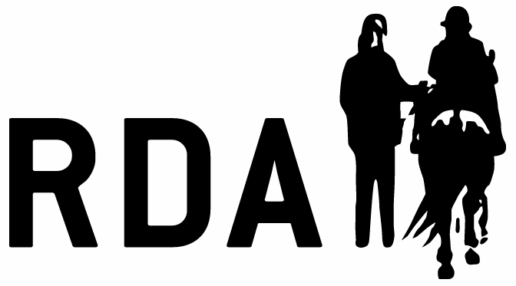

CERTIFICATE OF COMPETENCE
Vaulting Riding Hats

TO BE COMPLETED BY AN ADVANCED VAULTING COACH

The below named participant has been deemed competent to compete at RDA Vaulting Competitions, for barrel and/or with an equine, as indicated below, without the requirement of wearing a riding hat as stated in the RDA Group and Competition rulebook 2025. This is for the duration of the 2025 season only.

Tick all that apply for the exemption.

c Barrel
c With an Equine
PARTICIPANT Name: …….……………………………………………………………………….…………………………………………………

rda Group: …………………………………………………………………………………………………………………………………………….

We understand that this may need to be reviewed and updated as necessary with any changes to the environment, equipment, equine or participant and the requirement to compete with a hat may be reinstated.

PARTICIPANT SIGNATURE (or Parent/Guardian if participant is under 18 years of age):
………………………………………………………………………………………………………………………………………………………………….

DATE: …………………………………………………………………………..

VAULTING or BARREL VAULTING COACH NAME: ...……………………………………………………………………………..

SIGNATURE: ………………….………………………………………………………………………………………………………………………….

DATE: …………………………………………………………………………..

ADVANCED COACH NAME: …………………………………………………………………………………………………………………………

SIGNATURE: ………………….……………………………………………………………………………………………………………………………

DATE: …………………………………………………………………………..

Please return via post/email to either coaching@rda.org.uk or RDA National Office Lowlands Equestrian Centre, Old Warwick Road, Shrewley, Warwickshire, CV35 7AX
A copy of this should be retained by the Group.

