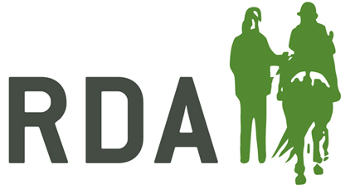

DISCLOSURE AND BARRING SERVICE (DBS)
Completing a DBS application 2018

DBS information (England &Wales)
The Disclosure and Barring Service is a government service which helps employers and voluntary organisations make safe recruitment decisions and prevent unsuitable people from working with vulnerable groups, including children.
As of the 30th of September 2018 RDA UK will no longer act as an umbrella body and carry out checks for RDA Groups in England and Wales. Below we have listed two companies which you can process your checks through:
Paper applications:
When you are ready to switch over to an alternative paper form provider you can contact DiscloSURE on:
Phone: 01702 558431
Email: startup@disclosesure.co.uk
You will be required to use new forms specific to that organisation so once you have switch please dispose of any remaining RDA purple forms.
Online applications:
We currently use a company called Disclosure services to process online applications. You can have your admin area switched over or sign up to using the service by completing a form of agreement. Please contact lcartwright@rda.org.uk for a copy of the agreement or for more information regarding switching over.
There is no requirement to use the new contacts that RDA UK have suggested to apply for a certificate, if the RDA Group feels there is a more convenient local method of completing the check. RDA groups will now be required to DBS check all volunteers at their group that directly participate with group sessions, these are to be renewed, or the status of a certificate checked via the Update Service, every three years.

What level check is required by RDA applicants?
Enhanced Check
This check’s for spent and unspent convictions, cautions, reprimands and final warnings plus any additional information held locally by police forces that’s reasonably considered relevant to the position applied for. This is the minimum level of check required by those, aged 16 and over, involved in an RDA session and is the level required by most RDA volunteers in supervised roles.

Enhanced Check with additional Barred List Checks
This checks the same as above with the addition of the appropriate DBS Barred Lists. This is the level of check required by those who are in a position of regulated activity where the role is described or equivalent to: Coach, Session Leader / Organiser, Centre / Yard Manager, RDA carriage driving coach and the role requires the individual to work with children.

Changes to the ID validation sheets
There are new guidelines for identification checking which can be found on the ID validation sheet dated December 2017. The main changes include the addition of Bank/ Building society statements for all countries outside the EEA (the branch must be in the country where you live and work) and the removal of work permits/ visa and certificate of British nationality.

GROUP 1 |  | Y | GROUP 2a | Y
Current Valid Passport – Any Current and valid passport |  |  | Marriage/civil partnership certificate (UK and Channel Islands)
 |  |  | Birth certificate – issued after time of birth (UK, Isle of Man and Channel Islands)
Adoption Certificate (UK and Channel Islands)
Current Driving Photo Licence – photo card. (Full or Provisional) UK / Isle of Man / Channel Islands/EEA |  |  | Current Driving Photo Licence – photo card. (Full or Provisional) All countries outside the EEA (excluding Isle of Man & Channel Islands)
 |  |  | Current Driving Licence – paper version issued before 1998 (Full or Provisional) UK / Isle of Man / Channel Islands/EEA
 |  |  | HM Forces ID Card (UK)
Birth Certificate (UK, Isle of Man & Ch. Islands) – issued within 12 months of date of birth:  including those issued by UK authorities overseas, such as Embassies, High commissions or HM Forces (photocopies not acceptable) |  |  | Firearms Licence (UK, Channel islands & Isle of Man)
 |  |  | GROUP 2b | Y
 |  |  | Bank/Building society statement* (UK & Channel Islands or EEA)
 |  |  | Bank/ Building society statement* (All countries outside the EEA. The branch must be in the country where you live and work)
 |  |  | Bank/Building Society account opening confirmation letter* (UK)
 |  |  | Utility bill* (UK) electricity, gas, water, telephone (NOT mobile phone)
Biometric residence permit. (UK) |  |  | Mortgage statement** (UK or EEA)
 |  |  | Council Tax statement (UK & Channel Islands)**
 |  |  | Benefit statement* (UK) e.g. Child Allowance, Pension
 |  |  | Credit card statement* (UK or EEA)
 |  |  | Financial statement** e.g. pension or endowment (UK)
 |  |  | P45/P60 statement** (UK & Channel Islands)
 |  |  | Letter from Head Teacher or College principal (UK) for 16-19 year olds in full time education , only used in exceptional circumstances if other documents cannot be provided – must still be valid
 |  |  | Letter of sponsorship from future employment provider (non-UK/EEA) valid only for applicants residing outside of the UK at time of application
 |  |  | Cards carrying the PASS accreditation logo (UK, Isle of man & Channel Islands) – must still be valid
 |  |  | EU National ID card – must still be valid
 |  |  | Central or local government, government agency, or local council document giving entitlement eg from the department for Work & Pensions, the Employment Service, HMRC* (UK & Channel Islands)

DBS – PAPER FORM

Complete sections W & X on the back of the purple form and provide to the applicant to complete in their own time, along with the information slip about the update service.
Once the applicant has received their certificate they must then bring it to the RDA group to be seen by the Safeguarding Officer.
RDA National Office will check, sign and send the forms on to Disclosure & Barring Services, who will complete the relevant checks and issue the applicant with a certificate.
After checking the form for common mistakes please send the form, ID validation sheet and a cheque for the application to the RDA National Office.
Check the applicant’s three forms of ID and complete an ID validation sheet, please ensure you are using the form dated December 2017.
Top 5 Mistakes on Application Forms
There are common mistakes made on DBS application forms which cause delays in getting the application processed and incur extra postage charges in returning applications. Please ensure that all forms are carefully checked before sending on to National Office for processing.
- Missing forenames, including middle names
Names must be included IN FULL and this also applies to the full name history. Please do not use nicknames or abbreviations

- Partially-completed dates
Other than the date of birth, all dates should be listed in MM/YYYY format. Dates between name and address changes should be consecutive, with no gaps. (Overlapping dates are fine) If a volunteer has listed the dates in a DD/MM/YY format please cross through it and rewrite in a MM/YYYY format next to it

.
- Incorrect driving licence number
Section A23 should give the applicants driving licence number. The full licence number needs to be inserted at this section (approximately 16 - 18 characters long and usually beginning with the first five letters of the surname). You can check that the applicant has included both their first and middle name from the number given as seen below.

- Correct ID validation sheet
As of December 2017 we have a new ID validation sheet please check three different ID’s for each applicant as instructed on the new sheet. These are available on our website and from National office.

- All forms must come with payment
If completing a paper form please enclose a cheque when sending or if completing online use the link at the end of the application to pay via PayPal. Fee’s are as follows:
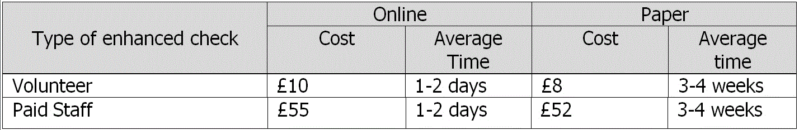

Completing the back of the forms
When completing your DBS forms, Section X must be completed in the following way, remembering to also add the group name in section 62:
If the form is for a standard volunteer please fill in as below:
If the form is for an individual who has taken on the role which is listed as above (regulated activity) please fill in the form as seen below:
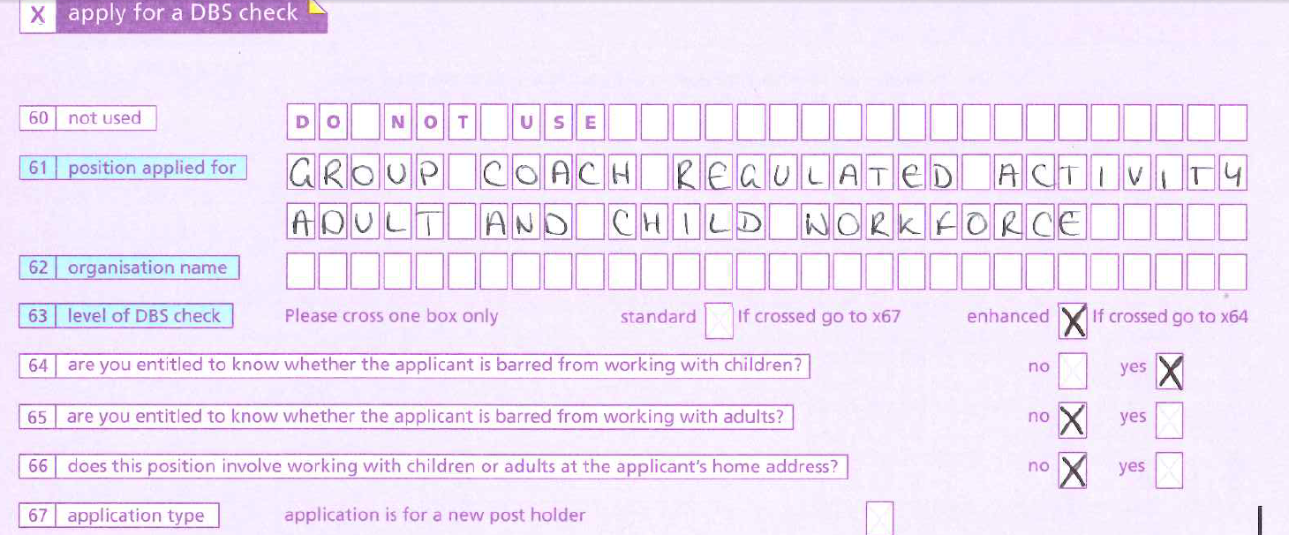

The definition of regulated activity
What does it mean to Groups?
Prior to the changes of legislation in 2012 all activity within RDA was deemed to be regulated. Under the 2012 legislation, there are only specific roles that fall within the definitions of regulated activity.
The roles are listed below:
- Coach (not assistant coach)
- Session Co-ordinator
- Centre Manager / Yard Manager
- Carriage Driving coach
You will notice in form images I have written “Adult and Child Workforce” this would apply to some groups who cater for both Adults and Children. If you cater for just children then please just write
‘Child Workforce’
If you cater for just adults, please write:
‘Adult Workforce’
Question 62 – Please put the name of your RDA Group in this section.
Question 63 – ALL Applications need to be for an ENHANCED CHECK, irrespective of the role in the Group.
Question 64 – Anyone with one of the 4 regulated roles above, working with children for some or all of the time, should say YES. All other applications should state NO. If you are a coach for instance and you only work with adults you do not need to have the child barred list checked. However if you are a coach and work with children and adults this must be checked.
Question 65 – All applications for RDA will say NO for this question.
Question 66 – All applications for RDA will say NO for this question.
SECTION Y – PLEASE LEAVE THIS SECTION BLANK – THIS IS FOR THE REGISTERED PERSON AT THE RDA NATIONAL OFFICE TO FILL IN. Writing in this section can delay the process as it can make the registered person’s signature unrecognisable to the computers at Disclosure services.

DISCLOSURE SERVICES – ONLINE FORM

Contact National Office to sign your group up to online Disclosure services and obtain your password and username.
Once the applicant has received their certificate they must then bring it to the RDA group to be seen by the Safeguarding Officer.
.

Check the applicant’s three forms of ID and complete and keep a copy of the ID validation form for their records (you do not need to send these in to National Office for online), please ensure you are using the form dated December 2017.
Once payment has been received RDA National Office will log on to check, sign off and submit the application. If you receive an email saying the form has errors please forward onto Beth at lcartwright@rda.org.uk
Provide the applicant with the log on details to complete the form in their own time. We also now have a guidance sheet for the applicant that can be adapted for the group’s needs.
UPDATE SERVICE
DBS has released the Update Service which allows applicants to register to create a transferable online criminal record certificate.
The Update Service lets applicants keep their DBS certificates up to date online and allows organisations to check an applicant’s status online (with permission of the applicant). Subscribing to this service reduces the need to apply for multiple certificates when an individual moves from one job or organisation to another doing a similar role.
The benefits to the applicant
- Applicants will be able to take certificates from one job or voluntary position to the next – meaning they will spend less time filling in forms.

- Applicants will be able to give employers and other organisations permission to check their certificate online and see who has checked it. Meaning the checking process will be much faster as a result can be obtains instantly.
If an individual at your group wishes to subscribe they must do this within 19 calendar days of the certificate being issued. For more information on this please visit our website or follow the link below:
https://www.gov.uk/dbs-update-service
Registration to the update service lasts for 1 year and is free of charge for volunteers and £13 for paid staff. When registering, you are able to click automatically renew this will allow your certificate to be updated without any effort every year. If an individual at your Group requires a DBS check and is a subscriber to the service they will need show you their original certificate, complete an ID validation form and an update service form. The form can be found on the RDA website / running Your Group / Disclosure checks / DBS England and Wales. Please keep these in your groups documents for 3-6 months.

APPLY HERE
https://secure.crbonline.gov.uk/crsc/apply
“I had a DBS check done when I was a volunteer, now I am a coach do I need to do another?”

Yes if you teach children once you become an assistant coach, and are able to coach without supervision of other coaches, you are in a role of regulated activity and require the additional child barred list check.

“I only have two forms of ID can I still volunteer?”

All applicants must have three forms of identification. Often we can help you find a third ID without having to take an alternative route, which may have additional costs. If you are having trouble with this please contact Laura Cartwright at National Office to talk through your options.

“My certificate has been sent but it still has not arrived can I have a new one?”
If your DBS certificate was issued over 14 days ago and you still have not received it you can complete a reprint request up to 3 months (93 days) after the issue date. More information can be found at https://www.gov.uk/government/publications/dbs-certificate-reprint-guide/dbs-certificate-reprint-guide
“Can I track my application?”
Yes, you can use your form reference number and date of birth to track your application. This can be found on the front of your purple form starting with F010 or can be requested from National office. Online reference numbers can be requested normally 24hrs after submission. The website you can track these on is:
https://secure.crbonline.gov.uk/enquiry/enquirySearch.do

If you have any more questions regarding DBS please contact Laura Cartwright at National Office.
Riding for the Disabled Association
T: 01926 476302
E: lcartwright@rda.org.uk

