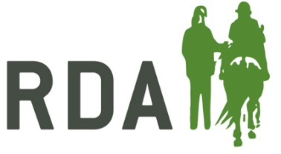
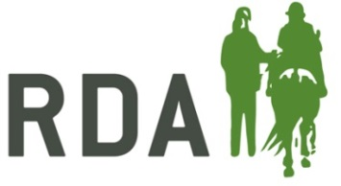
RDA COACH REVIEW FORM

COACH NAME:

GROUP: DATE:

Passport seen and up to date: Y/N
Safeguarding Certificate seen: Y/N Expiry Date:
PRE-VISIT NOTES:

BRIEFING NOTES:
OBSERVATION/EVIDENCE Essential Desirable

Capability |  | A |  | C |  | P | Evidence (MUST be included where action required)
Pre Session Checks
Plan for a suitable and progressive session | A |  | C |  | P
Risk assessment | A |  | C |  | P
Riders and volunteers welcomed / briefed | A |  | C |  | P
Equines and tack fit for the job | A |  | C |  | P
Mounting and Dismounting
Safe and effective mounting and dismounting |  | A |  | C |  | P
Knowledge & Rapport with Riders
Preparation and communication | A |  |  | C |  | P
Medical conditions and contra-indications | A |  |  | C |  | P
Involvement and progression for all | A |  |  | C |  | P
Coaching Skills
Listens / questions to engage & develop riders | A |  |  | C |  | P
Positive behaviour and language | A |  |  | C |  | P
Feedback provided to riders | A |  |  | C |  | P
Technical Instruction
Position and posture | A |  |  | C |  | P
Use of aids | A |  |  | C |  | P
Equine interaction | A |  |  | C |  | P
A: Action required as falls below competent standard, C: Competent, meets standard, P: Proficient, exceeds standard
(see accompanying capability table for details)
All of the essential capabilities must be met along with at least 3 of the 5 desirable capabilities for Group Coaches.
All capabilities must be met with at least four Proficient capabilities anywhere for Coaches.
Take a photo of this form once completed and send to the coach and RDA National Office.

NOTES FROM POST-OBSERVATION DISCUSSION
COACH REFLECTIONS
DISCUSSION AND FEEDBACK
From Coach Developer
AGREED DEVELOPMENT PLAN
GOAL |  | WHAT I NEED TO DO | SUPPORT I NEED | TARGET DATE

This review is evidence that the coach REMAINS / IS NOT at the standard required to coach within RDA Group sessions, in line with their qualification.

Signature of Reviewer: Name of Reviewer:

Signature of Coach: Date:

