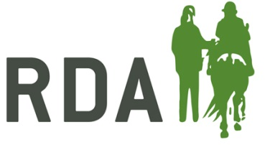**RDA Coach of the Year**

An individual who has made a significant contribution to coaching, has a track record of providing excellent support and

opportunities, and is an inspirational and positive role model.

**NOMINATION FORM**

**Nominator Details (your details) –** Information required for acknowledgements and queries

|  |  |
| --- | --- |
| **I am making this nomination**  - Please circle box as appropriate | On behalf of my RDA Group  As an RDA Volunteer  As an RDA Participant  As a parent/carer  As a teacher/TA of a participant  **Other description – please state** |
| Nominator’s full name and title |  |
| Preferred Contact information |  |

**Nominee details**

|  |  |
| --- | --- |
| **Name of Nominee** |  |
| **Name of RDA Group & Coaching Qualification** |  |

Reasons for nomination in a max of 400 words: please give details below, or on a separate sheet, as much information as you can about your nominee’s impact on RDA at Group, County, Region or National level.

Personal characteristics should be included, for example:

* Dedication
* Leadership
* Positive attitude
* Please note that nominations are presented to the judges as they are submitted and marks may be lost if the content is unclear.

|  |  |
| --- | --- |
| Name of Nominee |  |
| Please outline the reasons for your nomination, including specific examples of the impact they have had on those they have coached: | |
|  | |

**CLOSING DATE FOR RECEIPT OF NOMINATIONS** – 19th August 2022

**Return to; RDA, Lowlands Equestrian Centre, Old Warwick Road, Shrewley, Warwickshire, CV35 7AX**

**For further information or help, please contact Alex Walker on   
01926 405971 /** [awalker@rda.org.uk](mailto:awalker@rda.org.uk)