RDA Showjumping Level 3+ Competition Judging Sheet

Name:
No:
Group:
Venue:
Date:

Scale of Marks
0 =Not Executed 1 =Very Bad 2 =Bad 3 =Fairly Bad 4 =Insufficient
5 =Sufficient 6 =Satisfactory 7 = Fairly Good 8 = Good 9 = Very Good 10 = Excellent

 | Max. Mark | Judge’s  Mark | Penalties | Judge’s Comments
Quality of pace and preparation and approach to Start line (from the *bell sign to the start.)  *see course plan | 10
Jump 1  (Hands, position & balance over fence) | 10
Jump 2  (Hands, position & balance over fence) | 10
Jump 3  (Hands, position & balance over fence) | 10
Jump 4  (Hands, position & balance over fence) | 10
Jumps 5  (Hands, position & balance over fence) | 10
Jumps 6  (Hands, position & balance over fence) | 10
Jump 7  (Hands, position, balance & line over fence) | 10
Jump 8  (Hands, position & balance over fence) | 10
Jump 9  (Hands, position & balance over fence) | 10
Fluency of finish | 10
 | TOTAL

Collective Marks | Max. Mark | Judge’s  Mark | Judge’s Comment
Assess the rider’s ability to control the horse/pony whilst riding the course in a balanced position in trot/ canter.  Ensure the rider rides through the finish. | 10
Assessment of the rider’s effectiveness in riding a quality canter on the approach to the  jump. | 10
Performance: correct lines, rhythm and way of going. Fluency of transitions. | 20
 | TOTAL

Total Marks (Max 150) = |  | Total Pens =
Final Score and Percentage =

Judge’s Signature: ……………………………………….……………

Date: ……………………………………….……………

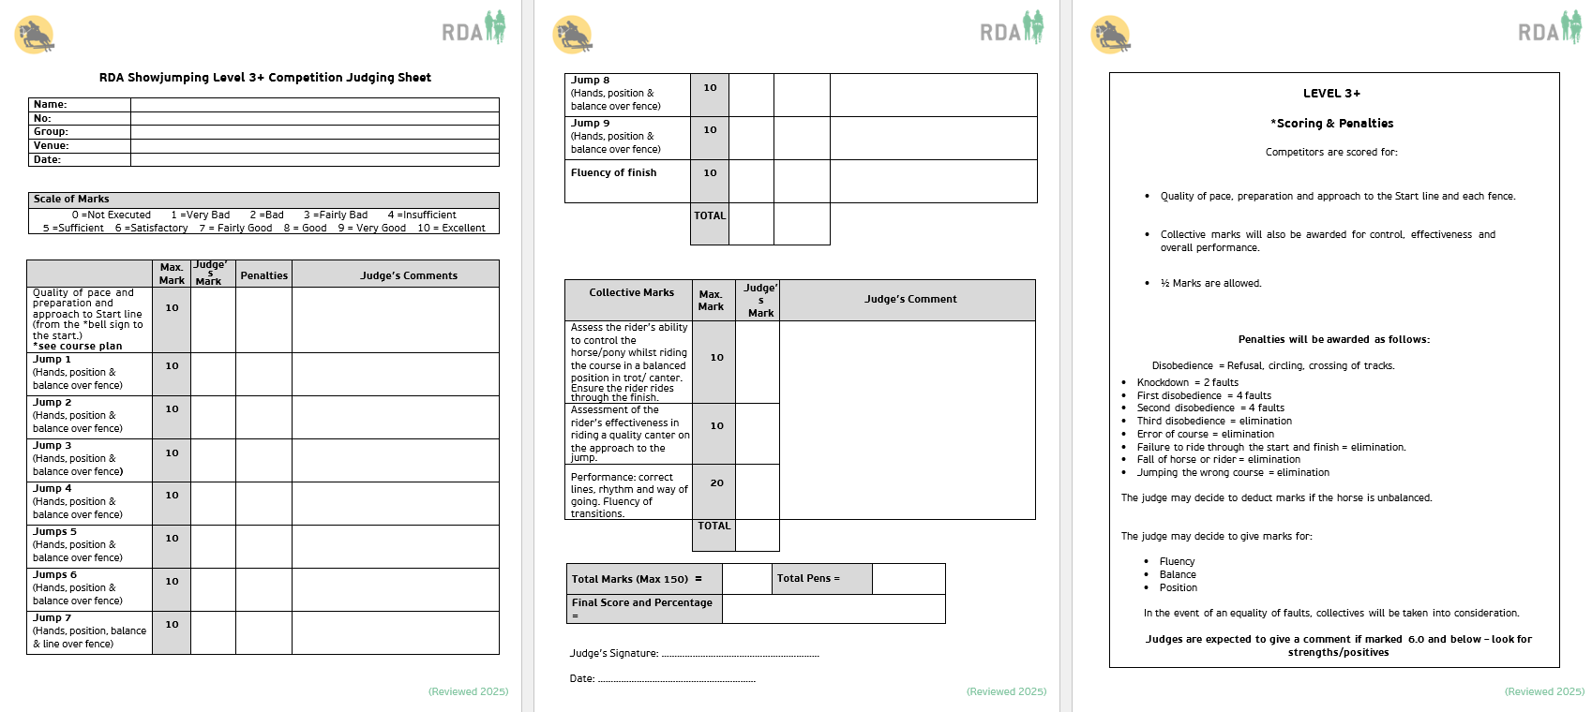
LEVEL 3+
*Scoring & Penalties

Competitors are scored for:
- Quality of pace, preparation and approach to the Start line and each fence.

- Collective marks will also be awarded for control, effectiveness and overall performance.

- ½ Marks are allowed.

Penalties will be awarded as follows:

Disobedience = Refusal, circling, crossing of tracks.
- Knockdown = 2 faults
- First disobedience = 4 faults
- Second disobedience = 4 faults
- Third disobedience = elimination
- Error of course = elimination
- Failure to ride through the start and finish = elimination.
- Fall of horse or rider = elimination
- Jumping the wrong course = elimination
The judge may decide to deduct marks if the horse is unbalanced.

The judge may decide to give marks for:

- Fluency
- Balance
- Position

In the event of an equality of faults, collectives will be taken into consideration.

Judges are expected to give a comment if marked 6.0 and below – look for strengths/positives

