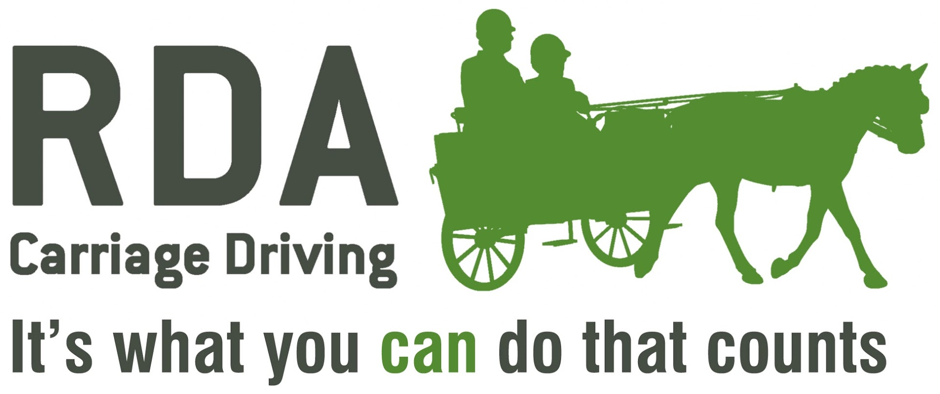The Dudley Smith Award 2024
RDA Carriage Driving is indebted to Susan Dudley-Smith for wishing to recognise our ‘unsung heroes’. Each Year RDA will acknowledge an individual volunteer who has made an important contribution to RDA Carriage Driving through hard work and often unsung efforts.
The Award will be presented at the National Championships Carriage Driving Presentations
on Friday July 12th 2024
Award Criteria: -
- The award is open to any person who is a regular volunteer at an RDA Carriage Driving Group. Nominations should not only be about the role within the Group or length of service (although these may be important).
- Nominees should have made an important contribution to RDA Carriage Driving at a Group, County, Regional or National level.
- The Awarding Committee will be looking for evidence that this person has gone beyond what might normally be expected.
Name of Nominee: ………………………………………………………………………………………………………………………………………

Name of Group: ……………………………………………………………………………………………………………………………………………

Position within Group: …………………...…………………………………………………………………………………………………………….

County Position: ………………………………………………………………………………………………………………………………………….

Regional Position: ……………………………………………………………………………………………………………………………………….

National Position: ……………………………………………………………………………………………………………………………………….

Reasons for Nomination: ……………………………….………………………………………………………………………………………….

………………………………………………………………………………………………………………………………………………………………………

………………………………………………………………………………………………………………………………………………………………………

………………………………………………………………………………………………………………………………………………………………………

………………………………………………………………………………………………………………………………………………………………………

(Please continue on a separate piece of paper if necessary)

Nominators Name: ………………………………………… Signature: ………………………………………………………….

Telephone: …………………………………………… E-mail: ………………………………………………………………………

Second Nominators Name & Signature: ………………………………………………………………………………………….

This form should be returned by email to the Coaching Team (coaching@rda.org.uk ) at RDA National Office, and copied to the CD Lead (cdlead@rda.org.uk)
by Thursday 27th June 2024
RDA National Office, Lowlands Equestrian Centre, Old Warwick Road, Shrewley, Warwickshire. CV35 7AX

