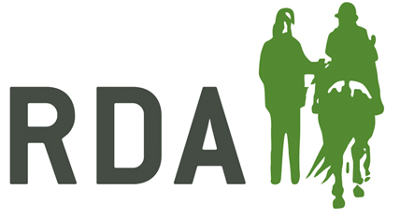
Equine Flu Vaccination Policy

Due to the outbreak of Equine Flu during 2019, there has been a lot of discussion across the British Equestrian Federation (BEF) about the most appropriate response to protect horses and all of our work. An outbreak of Equine Flu is a serious issue of equine welfare and would have a big impact on the day to day running of RDA groups, as well as equestrian businesses and the industry as a whole.
As a result of this, and following research and advice from the Animal Health Trust and other veterinary experts, the BE (British Equestrian) is now requiring that all member bodies comply with stricter rules regarding vaccination of horses. Therefore, from 1 January 2020 RDA UK will require any horse that is owned by RDA, or that is deemed to qualify for the free vaccine scheme, to be vaccinated annually. Where possible, we are recommending that horses should be vaccinated every 6 months. It is also recommended that any other horse used by RDA should be vaccinated. This will ensure that we stay in line with both BE (British Equestrian) and the FEI rules.
It is also important to note that where horses are being taken to competition venues or outside venues for RDA activities, you should check that this vaccination regime is sufficient for that venue.
Free vaccination scheme for RDA
For a number of years, three pharmaceutical companies have generously supplied free vaccines for RDA horses and ponies: Zoetis, MSD Animal Health and Boehringer Ingelheim. RDA horses and ponies qualify for the scheme if they ‘contribute a significant amount of their time to doing RDA activities’. The vaccine companies involved have been supplying several thousand doses every year and it is important to ensure that their generosity is not abused. Please be aware, it covers the cost of the vaccine only and not the cost of any call out charges made by a vet.
Claiming a free vaccine is easy: just fill out the form on the MyRDA website in ‘Horses & RDA’ ‘Vaccinations’. The form can be signed by a Trustee of the group and the Vet who administered the vaccines. The group should keep the original and then send a copy to the relevant participating pharmaceutical company. This will depend on the type of vaccine administered, your Vet will advise if you aren’t sure. The Veterinary practice will then be reimbursed usually on a quarterly basis.
If you have any queries regarding vaccinations please do not hesitate to get in touch with ebayliss@rda.org.uk

