**Equine Influenza and Tetanus Vaccine Claim Form**

***Please check that BEFORE any vaccinations are administered, that they are supplied by one of the pharmaceutical companies that support this reimbursement scheme***

* **Boehringer Ingelheim Ltd, Ellesfield Avenue, Bracknell, Berkshire RG12 8YS**
* **MSD Animal Health, Companion Animal Business Unit, Walton Manor, Walton, Milton Keynes, Buckinghamshire MK7 7AJ**
* **Zoetis UK Ltd, Walton Oaks, Dorking Road, Walton-on-the-Hill, Tadworth, Surrey KT20 7NS**

***Please circle which brand of vaccine is being administered:***

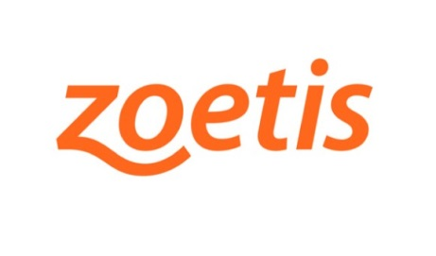



**Section A – Veterinary Surgeon**

I certify that I have administered (number of doses)

Of (name of vaccine)

To equines in true use with the RDA group stated below. These were certified as being in regular and fair use for the RDA group.

Signed Vet Surgeon on (date)

Name Block capitals

Address

Tel No. Email

**Section B – Trustee of the** **group**

I certify that we maintain a list of equines so injected and shall, ensure to the best of the group’s ability, ensure that the immunisation programme is maintained.

Signed a Trustee on (date)

Name Block Capitals

Address

Tel No. Email