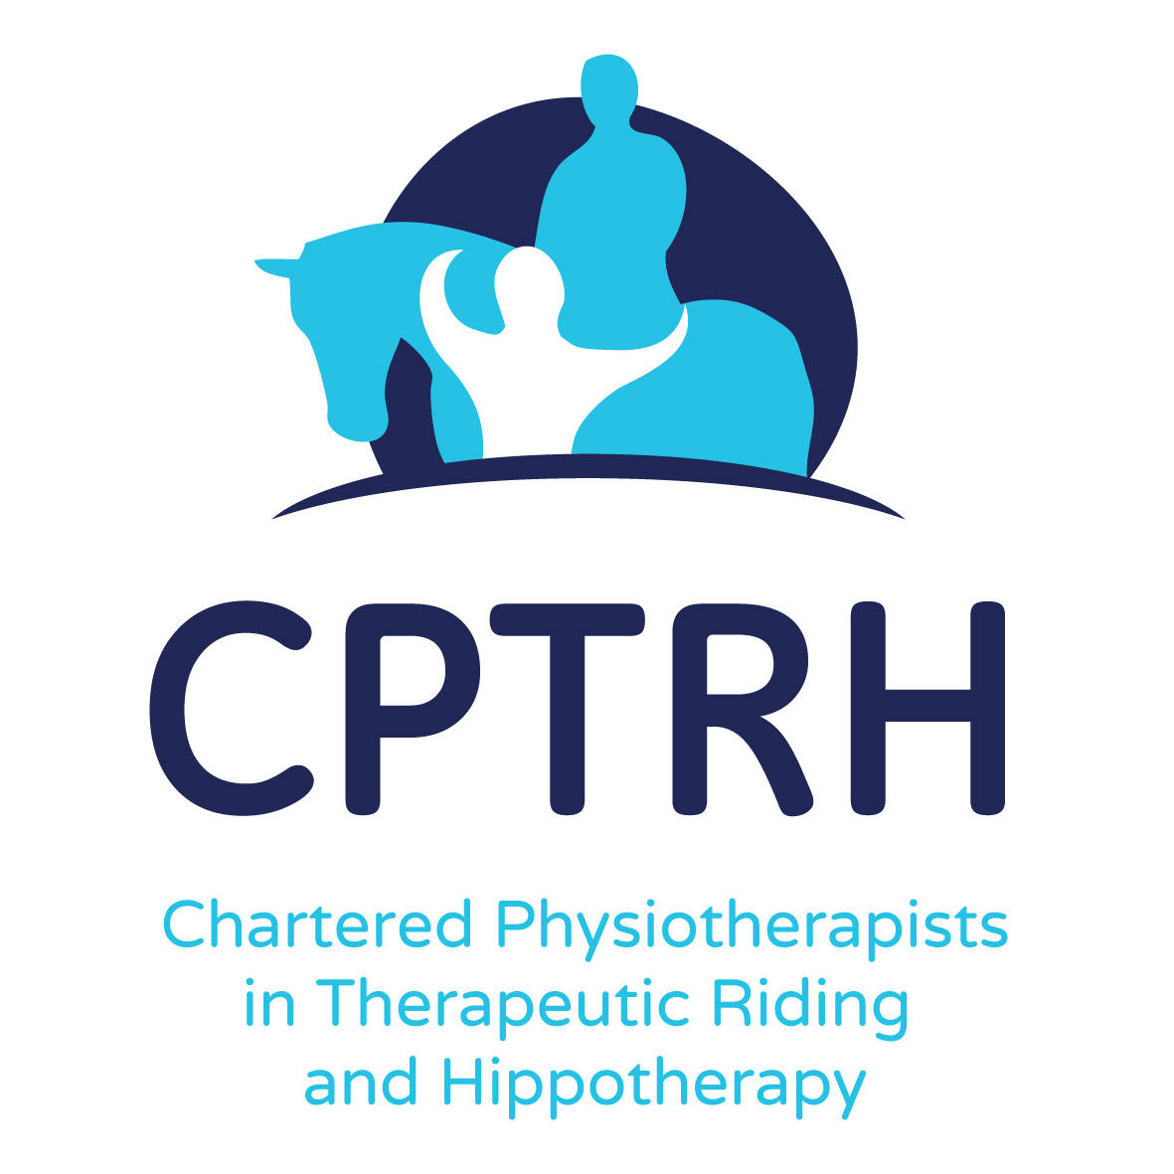







**HETI(UK) SPRING FORUM 2019**

Will be hosted by CPTRH

On: Saturday 13th April 2019 10am – 4pm

At: The Northern Racing College, Doncaster DN11 0HN

‘Gathering Evidence with Case Studies

How to carry out and write up a case study

Outcome measures to use

Presentation of case studies

Observation of RDA riders

Workshop on planning case studies

Using case studies to create a library of evidence

Something for everyone, whatever your specialised area of equine assisted activities, therapeutic riding or hippotherapy

Lunch and drinks included

£10 pp

To register a place or all enquiries to:

Elizabeth Beckerlegge [elizabeth@beckerlegge.com](mailto:elizabeth@beckerlegge.com) or 07902 465 448