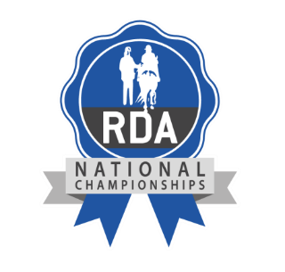

RDA National Championships 2024

Horse Substitution

Group Name

Rider Name

Original Horse Name

New Horse Name

Class Number/s

Reason for substitution

Group Representative Name (please print)
Signature from Group Representative
Group Representative Role

All horse and rider/driver combinations must be deemed suitable and equines must have been assessed and approved to do RDA activities by a Regional Coach or someone nominated by Regional Coach.

I confirm that the above equine and rider/driver combination is suitable for competition at the RDA National Championships.

Regional Role

Name

Signature

Please return to Secretary’s office at National Championships or email to Fiona Harris fharris@rda.org.uk

