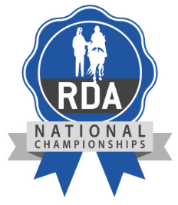

Nomination Form for National Championships Endurance Classes
Please note to nominate a Participant you must be a Regional or County Coach

Participant Name:

Participant RDA Group:

Class Participant wishes to entre at National Championships (please circle)
1km 2km 3km 5km

Name of person nominating Participant:

RDA Role:

Date:

Signature:

Please email to kobrien@rda.org.uk

