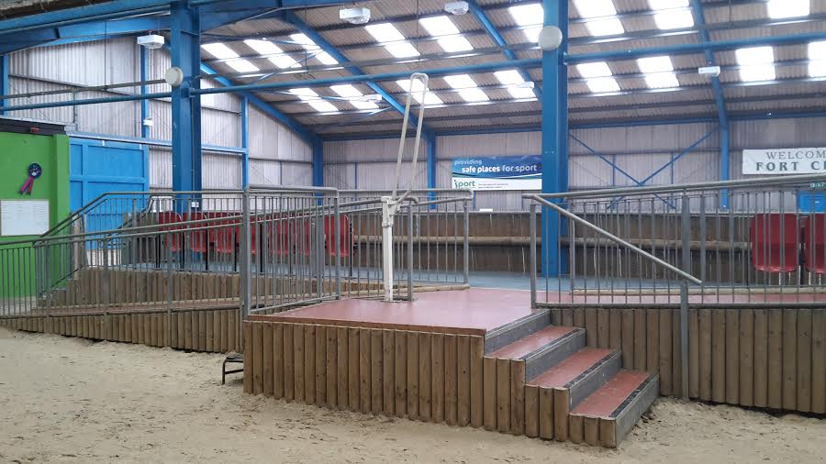

**Fixed Mounting Ramp – Fort Centre**