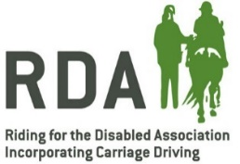
Pre-Purchase Examination Policy Statement

Introduction
Equines play a vital role within RDA and purchasing suitable horsepower for an RDA Group can be daunting from a financial and practical point of view. With this in mind we have engaged the services of Bryan Hallows, RDA Regional Vet and Veterinary Expert Witness www.vetexpertwitness.com

He has kindly compiled a comprehensive guide for RDA groups to use when considering purchase or loan of an equine. This takes you through each stage of a PPE and what to expect, as well as a guide on cost and samples of the forms that Vets use. This guide will be available to all groups, REA’s and RV’s.

Background
It is recognised that equines are the base upon which everything we do is built. We must strive to ensure that we have the soundest base possible, and to this end it is expected that every equine owned or loaned to an RDA Group has a Pre-Purchase Examination to ensure it is healthy and fit for purpose. Group Trustees are responsible for exercising due diligence when spending charitable funds and the purchase of equines is quite often a larger financial commitment and hopefully a long-term investment. Failing to ensure that any equine bought is suitable could involve a considerable financial and practical burden on a group in both vet bills, on-going care and lack of an equine to use in RDA sessions.

This policy statement should be adopted as a Code of Practice throughout RDA to help safeguard charity funds and assist RDA Groups in finding a suitable equine.

Policy Principles:
- RDA expects that all horses that are owned or long-term loaned to RDA Groups should have the minimum of a two stage pre-purchase examination

- Advice on this matter and any further information is readily available. Please email the Equine team at RDA National Office for details: groupsupport@rda.org.uk

