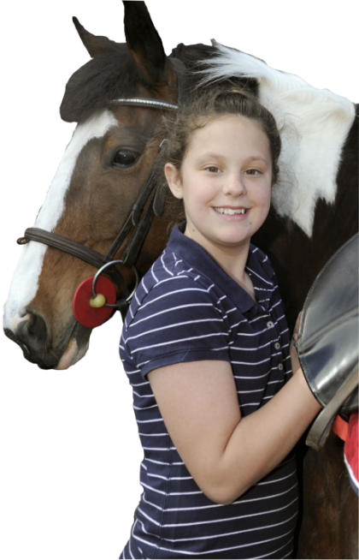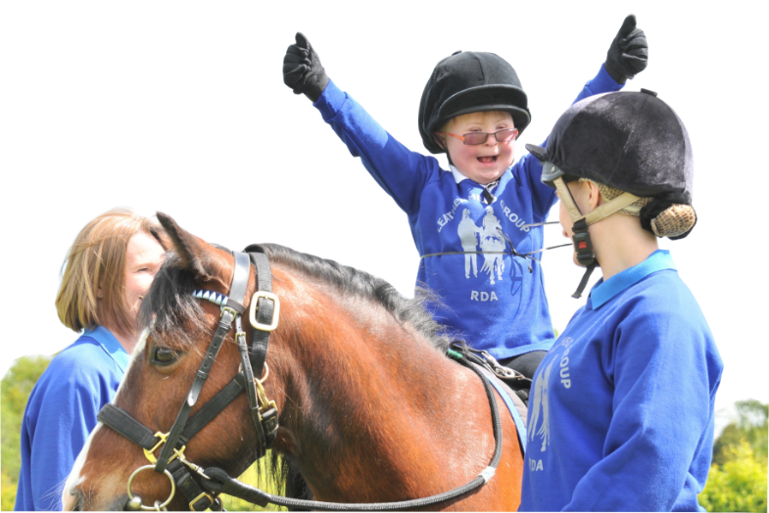

**GROUP**

**SAFEGUARDING OFFICER**

Place Photo of Safeguarding

Officer here.

**RDA National Office Safeguarding Team:**

**For reporting Concerns only:** [safeguarding@rda.org.uk](mailto:safeguarding@rda.org.uk)

Stef Brazier [sbrazier@rda.org.uk](mailto:sbrazier@rda.org.uk) **01926 476302**

Marisa Bretherton-Mackay [marisa@rda.org.uk](mailto:marisa@rda.org.uk) **01926 405973**

**Helplines:**

NSPCC Child Protection Helpline (not 24 hours) **0808 800 500**

Childline **0808 800 5000**

Ann Craft Trust (Adult Safeguarding)  **0115 951 5400**

Name: ______________________________

Telephone: ___________________________

RIDE DAYS: ___________________________