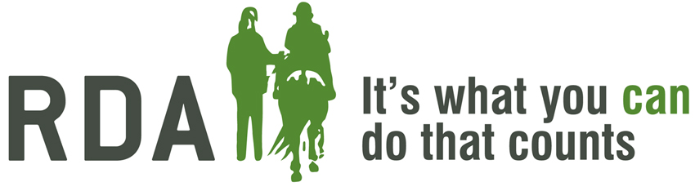

Mounting & Dismounting
Date:
Venue Details:

Learning Outcome: by the end of this module as a volunteer you should feel confident to be involved with the mounting procedure at your group.
PROGRAMME
Introduction – Aims and objectives of the module
Equine is suitable and properly trained to use the mounting facilities
Roles and Responsibilities of the mounting and dismounting team
Demonstrate the different styles of mounting and dismounting

Organiser Contact details:

