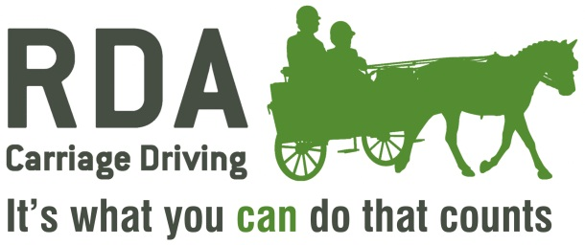
Form for Carriage Drivers to Drive with Single Reins with Coach sitting beside the driver.

N.B. A driver who can use Single reins, with a CD Coach beside them, should have passed Grade 3, if applicable, be capable of recognising possible dangers and be alert at all times.
Name of Carriage Driver:
Group:

Group Organiser Contact Details
Name:
Address:
E-mail:
Telephone Number:
Please include any notes below including any exclusions e.g. “not on the road” or “not with specific equines”, if deemed necessary. (Continue on separate sheet if necessary, and attach to this form).

The Carriage Driver may be reassessed at the request of any of the signatories.
If applicable - A copy of the Driver's RDA Test 3 Certificate should be attached to this form.

Role | Name | Signature for Single Reins
Carriage Driver
Group Organiser
Carriage Driving Assessor or CD Coach
Regional Driving Rep.
A copy of this form must be retained by the Group, and Regional Carriage Driving Representative and emailed to NATIONAL OFFICE coaching@rda.org.uk

Date:

