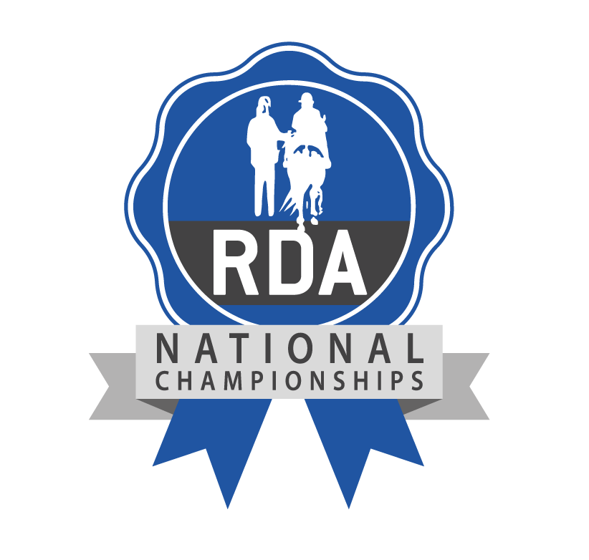
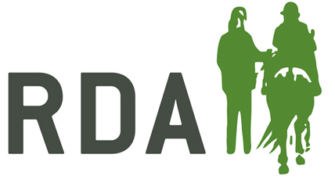

The Harvey Best All Rounder Cup

To be awarded annually to a horse/pony that has been proven to shine in all RDA activities and enables RDA participants to compete at the RDA National Championships.

Each Group may nominate one horse/pony annually for this award. The horse/pony must be competing at the RDA National Championships in the current year. Nominations must be submitted on this official form only, by 2pm 12th July 2025. No additional evidence will be allowed.

The Harvey Best All Rounder Cup 2024
Group: …………………………………………………………………………………………….…………………………………….
Group Contact: …………………………………………………………………………………………………………………….
Address: ……………………………………………………………………………………………………………………………….
………………………………………………………………………………………………………………………………………………
Tel: …………………………………………………….. Email: ……………………………………………………………………
Horse’s Name:
Age:
Please give the details of why your horse/pony should receive the Best All Rounder Cup 2024
I have verified the nomination on behalf of the Group’s Committee

Name:…………………………………………………………… Position:……….……………….……………….

Signed:………………………………………………… Date:………………………………

