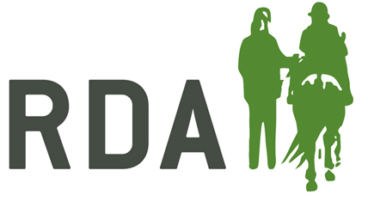

The Pat Straughan Medal of Commendation

To be awarded annually to a participant that has shown outstanding courage and determination to persevere and meet the challenge to ride and compete in RDA Dressage competitions.

Each Group may nominate one rider annually for this award. Nominations open from 1st May 2023 to 5pm on Saturday July 15th 2023 to allow judging to take place and award to be presented at National Championships. Nominations must be submitted on this official nomination form only. No additional evidence will be allowed. Email entries to ebayliss@rda.org.uk or drop into Secretary’s Office at National Championships.

Pat Straughan Medal Of Commendation 2023
Group: …………………………………………………………………………………………….…………………………………….
Group Contact: …………………………………………………………………………………………………………………….
Address: ……………………………………………………………………………………………………………………………….
………………………………………………………………………………………………………………………………………………
Tel: …………………………………………………….. Email: ……………………………………………………………………
Rider’s Full Name:
Age:
Please give the details of why your rider should receive the Pat Straughan medal of Commendation 2023
I verified the nomination on behalf of the Group’s Committee
Name:…………………………………………………………………………………………………………. Position:……….……………….……………………………………………………………………………..
Signed:………………………………………………… Date:………………………………………………

