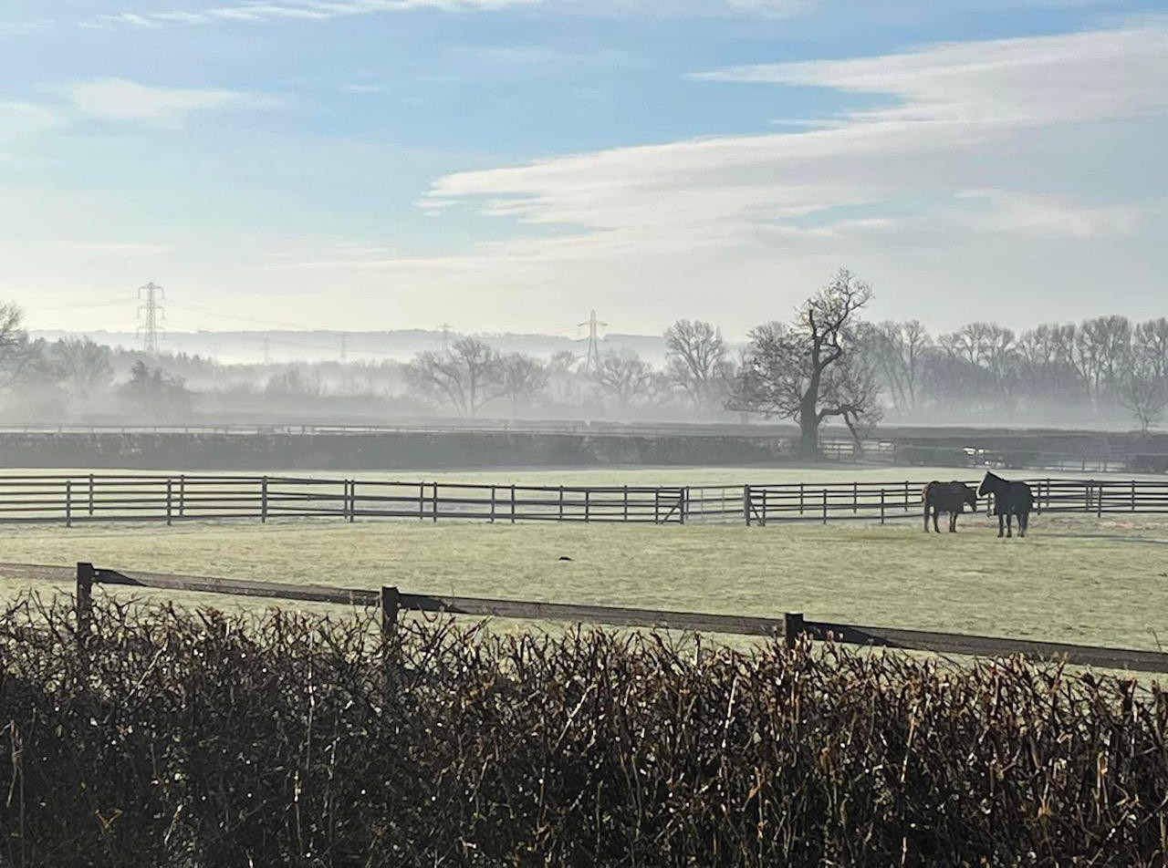
Belvoir Vale RDA Group
Coach Training

POSITION, POSITION, POSITION
WEDNESDAY 10th April 2024
10.30 AM – 2.30 PM BELVOIR VALE RDA GROUP
Colston Bassett, Nottingham NG12 3BJ

Trainers:
Jennie Wilkinson BSc (Hons) Physiotherapy Lesley Davies RDAC
Karen Thompson RDASC
An in-depth look at the position of the rider in walk, trot and canter. AM: Assessing and developing the position of the therapeutic rider. PM: Position of the rider in trot and making the first steps in canter.
Open to all levels of coaches and will count as the practical part of the Therapy & Medical Module and a CPD providing a reflection sheet is completed on the RDA website.
Numbers restricted to 30. £10 per person
Tea & Coffee will be provided. Please bring your own lunch.
Book before 29th March 2024
Booking Form

For further information email karen@kestevenrda.org.uk
or phone 07732 418848

Name:
Group:
Contact Details:

Please email the booking form to karen@kestevenrda.org.uk and pay by BACs transfer:
Nat West Account Name: Belvoir Vale RDA Sort code: 60-02-41 Account number: 69223874 using your surname or RDA group as a reference
or send the booking form along with a cheque made out to Belvoir Vale RDA to: Karen Thompson
34 Ninth Avenue Grantham
Lincs NG31 9TF

2

