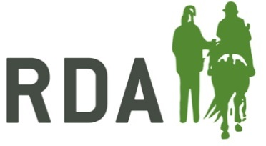
COVID-19 TRAINING RECORD SHEET 2020

To be used for household members accompanying a participant to help them take part in RDA sessions.

RDA Group:

Participant Name(s): Session Date(s):

Explanatory notes:

This training record is intended to replace the need for an individual Basic Training Record Card (green card) to be issued for the following types of helper:

- Those attending as a “household member” of a participant to help with their RDA session(s)

It is intended that this should simplify the system for this important group of helpers, so they do not need to complete a volunteer application form or disclosure check, but do need to complete this form, along with a Covid-19 volunteer consent form.

Groups are reminded that it is the responsibility of the Session Coach to ensure that the helper has received the appropriate training for their role, but also has the final say as to their suitability to help in the session.

By signing below, you agree that you have received the appropriate introduction to the Group environment and activities and acknowledge the RDA Health & Safety and Covid-19 Guidelines

Helper Name & Signature  Signature here confirms that training has been received. Please also initial under  ‘date training given in’ |  | . . . . . . . . . Date training given . . . . . . . . .  (helper please insert date and initial) |  |  | Signature of Coach
 |  | Appropriate dress, footwear & behaviour around horses | Providing assistance with mount/dismount | Side helping / Leading

This form should be kept with the participant’s records once completed.

