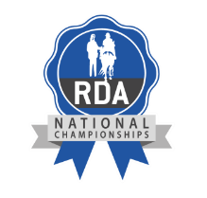
RDA NATIONAL CHAMPIONSHIPS
FILMING PERMISSION RELEASE FORM 2023

PARTICIPANT’S NAME
RDA GROUP
RDA REGION

In accordance with RDA UK’s Safeguarding policy, we will not permit photographs, video or other images of children, young people or adults at risk to be taken without consent. If under 18, consent must be obtained from the participant’s parent, carer or guardian.

RDA UK will take all steps to ensure any filmed entries are used solely for the purposes for which they are intended and as outlined below. If you become aware that these images are being used inappropriately, please inform us immediately.

________________________________________________________________________________________

NATIONAL CHAMPIONSHIPS FINALS – HARTPURY COLLEGE

I …………………………………………………………………………………………………….………………………….. (participant’s name) understand that the filmed recording of my entry will be live-streamed publicly in the broadcast of the 2023 RDA National Championships. I accept that this recording will be kept by RDA UK for no longer than 12 months after the competition, for training and review purposes, before being deleted.

Signed: ………………………………………………………………………………………………………………………………… Date: ……………………………….
Participant / Carer / Guardian (please delete as appropriate)

To the Participant/ Parent/ Carer/ Guardian: Please complete this form in full and return it ebayliss@rda.org.uk

