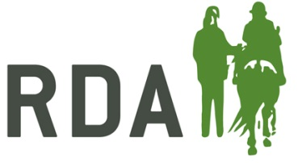**Young Coach of the Year**

This is an award for an outstanding coach aged 25 or under on the 1st of January 2022.

The individual who receives this award will have invested time in their development as a coach and made a significant impact on those they coach.

**NOMINATION FORM**

**Nominator Details (your details) –** Information required for acknowledgements and queries

|  |  |
| --- | --- |
| **I am making this nomination**  - Please circle box as appropriate | On behalf of my RDA Group  As an RDA Volunteer  As an RDA Participant  As a parent/carer  As a teacher/TA of a participant  **Other description – please state** |
| Nominator’s full name and title |  |
| Preferred Contact information |  |

**Nominee details**

|  |  |
| --- | --- |
| **Name of Nominee** |  |
| **Name of RDA Group & Coaching Qualification** |  |

Reasons for nomination in a max of 400 words: please give details below, or on a separate sheet, as much information as you can about your nominee’s impact on RDA at Group, County, Region or National level.

Personal characteristics should be included, for example:

* Dedication
* Leadership
* Positive attitude
* Please note that nominations are presented to the judges as they are submitted and marks may be lost if the content is unclear.

|  |  |
| --- | --- |
| Name of Nominee |  |
| Please outline the reasons for your nomination, including specific examples of the impact they have had on those they have coached: | |
|  | |

**CLOSING DATE FOR RECEIPT OF NOMINATIONS** – 19th August 2022

**Return to; RDA, Lowlands Equestrian Centre, Old Warwick Road, Shrewley, Warwickshire, CV35 7AX**

**For further information or help, please contact Alex Walker on   
01926 405971 /** [awalker@rda.org.uk](mailto:awalker@rda.org.uk)